- Execute the commands to add a new user and view the user details
- sudo adduser hasini [ To create a new user hasini with a home directory ]
- cat /etc/passwd [ To display the user account details stored in /etc/passwd ]
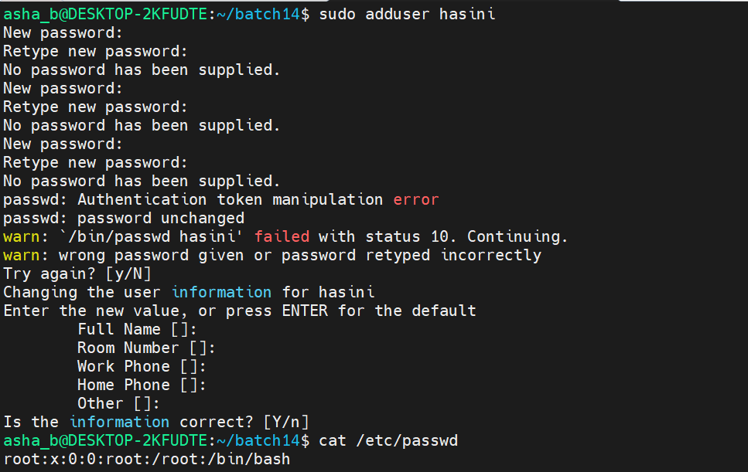

- sudo passwd hasini [ To set a new password for the user hasini ]
- sudo su [ To switch to the root user ]
- exit [ To come out of the root user session ]
- sudo su hasini [ To switch to the user hasini ]
- exit [ To come out of the hasini user session ]
- sudo addgroup learners [ To create a new group named learners ]
- sudo addgroup trainers [ To create a new group named trainers ]
- sudo usermod -G learners hasini [ To add the user hasini to the group learners ]
- cat /etc/group [ To display the group details and verify the group membership ]
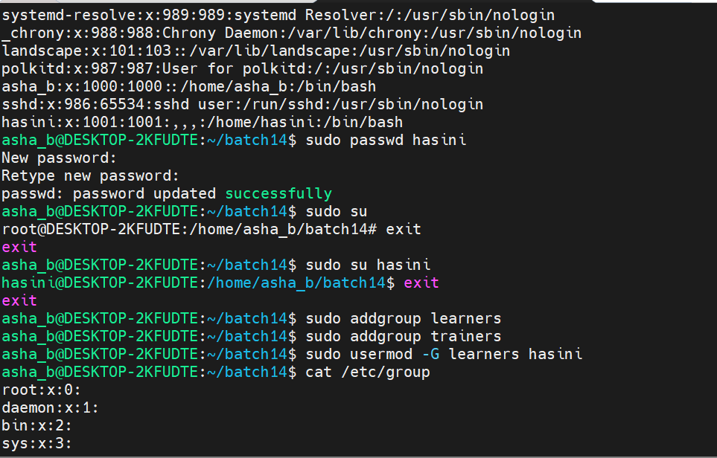

- Execute the commands to delete a user and a group
- sudo deluser hasini [ To delete the user hasini ]
- cat /etc/passwd [ To verify that the user hasini is removed from /etc/passwd ]
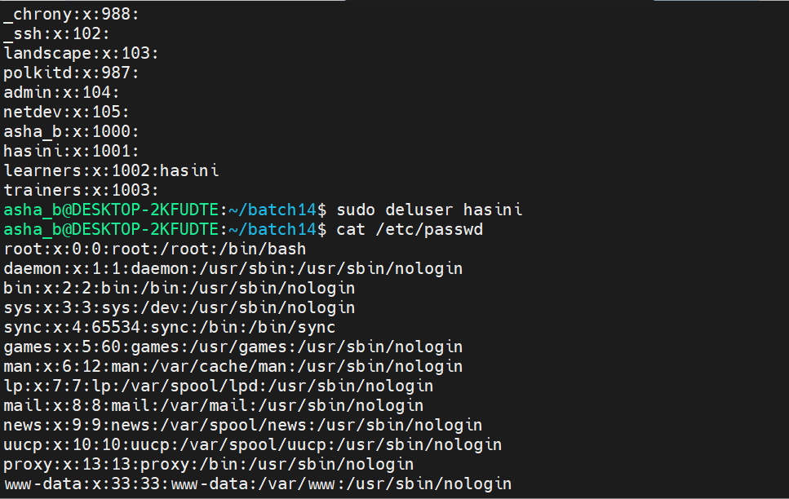
- sudo delgroup trainers [ To delete the group trainers ]
- cat /etc/group [ To verify that the group trainers is removed from /etc/group ]
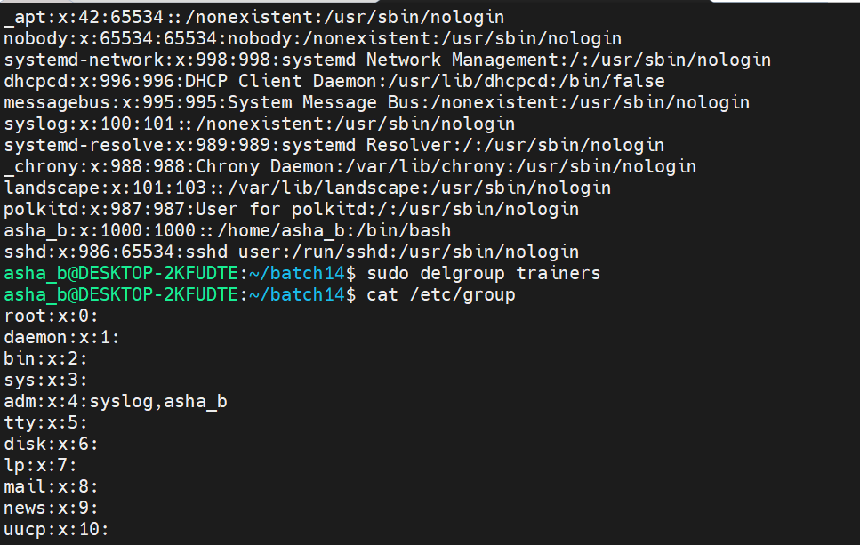

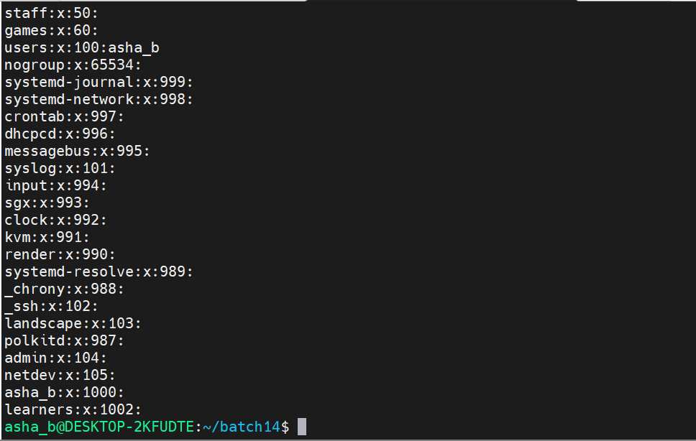

- Execute the commands to list files and change permissions using numeric mode
- cd batch14 [ To move into the directory batch14 ]
- ls [ To list the files and directories in batch14 ]
- ls -lrt [ To display the long listing with permissions, oldest entry first ]
- sudo chmod 777 d1 [ To give read, write and execute permissions to everyone for d1 ]
- sudo chmod 446 f8 [ To give r-- to owner, r-- to group and rw- to others for f8 ]
- ls -lrt [ To verify the updated permissions of d1 and f8 ]
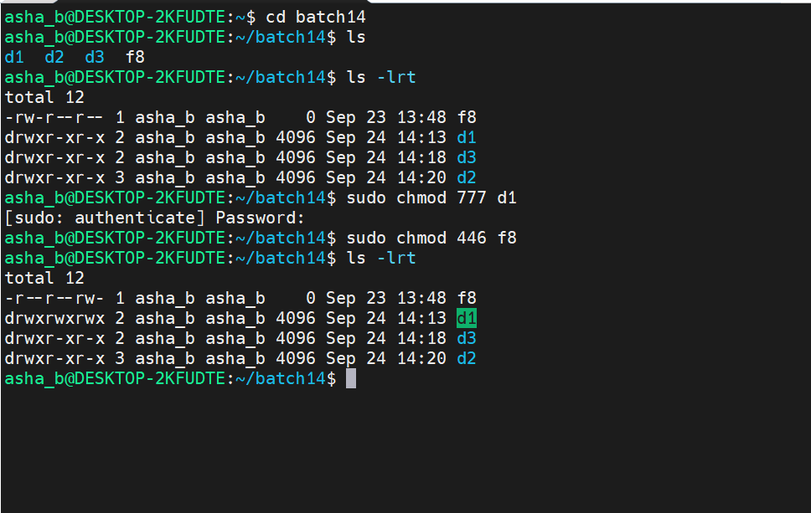

- Execute the commands to change permissions using symbolic mode
- sudo chmod o+r d2 [ To add read permission for others on d2 ]
- sudo chmod g-r d3 [ To remove read permission from the group on d3 ]
- sudo chmod g+w f8 [ To add write permission for the group on f8 ]
- sudo chmod u-w d2 [ To remove write permission from the owner/user on d2 ]
- sudo chmod g+x f8 [ To add execute permission for the group on f8 ]
- sudo chmod o-x d1 [ To remove execute permission from others on d1 ]
- ls -lrt [ To verify the updated permissions ]
- sudo chmod o-x,g-w,u+x f8 [ To change the permissions of owner, group and others on f8 in a single command ]
- ls -lrt [ To verify the updated permissions of f8 ]
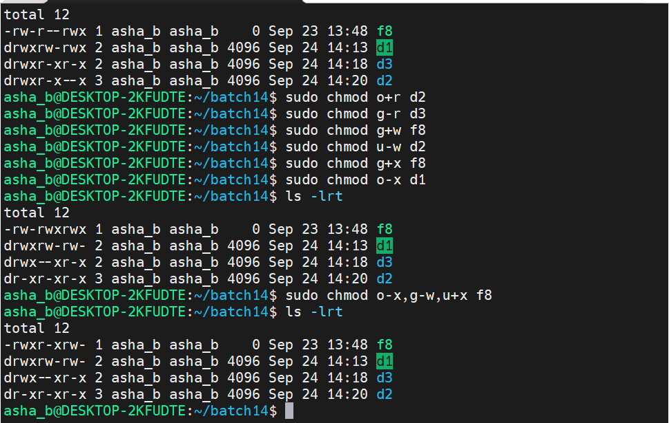

- Execute the command : chmod with ugo to change permissions for all users
- ls -lrt [ To display the current permissions of the files and directories ]
- sudo chmod ugo+w d2 [ To add write permission for the owner, group and others on d2 ]
- ls -lrt [ To verify that d2 now has write permission for all users ]
